Họ và tên : Vũ Văn Trọng

Mã số sinh viên : 20184206

ASSIGNMENT 4

#Laboratory Exercise 7, Home Assignment 4

.data

Message: .asciiz "Ket qua tinh giai thua la: "

.text

main:

jal WARP

print:

add $a1, $v0, $zero # $a0 = result from N!

li $v0, 56

la $a0, Message

syscall

quit:

li $v0, 10 #terminate

syscall

endmain:

#---------------------------------------------------------------------

#Procedure WARP: assign value and call FACT

#---------------------------------------------------------------------

WARP:

sw $fp,-4($sp) #save frame pointer (1)

addi $fp,$sp,0 #new frame pointer point to the top (2)

addi $sp,$sp,-8 #adjust stack pointer (3)

sw $ra,0($sp) #save return address (4)

li $a0,3 #load test input N

jal FACT #call fact procedure

nop

lw $ra,0($sp) #restore return address (5)

addi $sp,$fp,0 #return stack pointer (6)

lw $fp,-4($sp) #return frame pointer (7)

jr $ra

wrap_end:

#---------------------------------------------------------------------

#Procedure FACT: compute N!

#param[in] $a0 integer N

#return $v0 the largest value

#---------------------------------------------------------------------

FACT:

sw $fp,-4($sp) #save frame pointer

addi $fp,$sp,0 #new frame pointer point to stack’s top

addi $sp,$sp,-12 #allocate space for $fp,$ra,$a0 in stack

sw $ra,4($sp) #save return address

sw $a0,0($sp) #save $a0 register

slti $t0,$a0,2 #if input argument N < 2

beq $t0,$zero,recursive#if it is false ((a0 = N) >=2)

nop

li $v0,1 #return the result N!=1

j done

nop

recursive:

addi $a0,$a0,-1 #adjust input argument

jal FACT #recursive call

nop

lw $v1,0($sp) #load a0

mult $v1,$v0 #compute the result

mflo $v0

done:

lw $ra,4($sp) #restore return address

lw $a0,0($sp) #restore a0

addi $sp,$fp,0 #restore stack pointer

lw $fp,-4($sp) #restore frame pointer

jr $ra #jump to calling

fact_end:

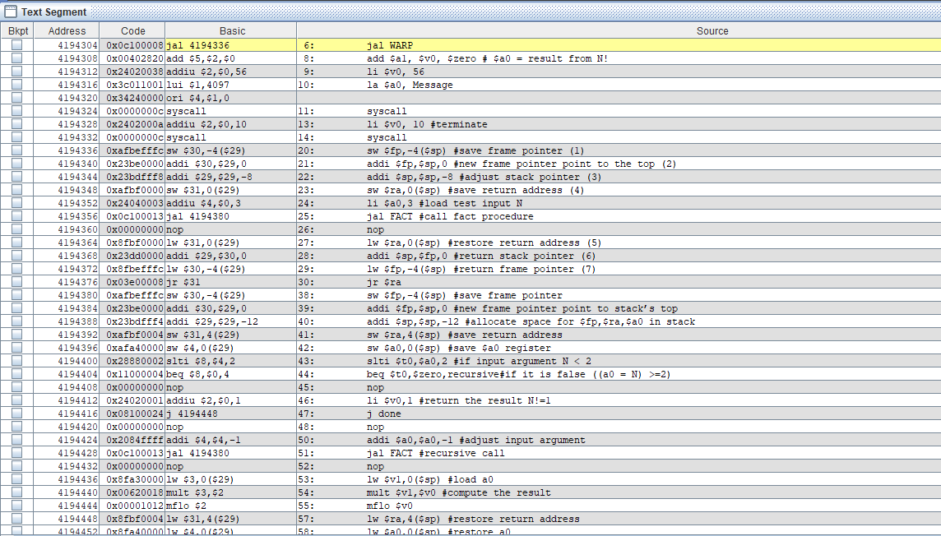

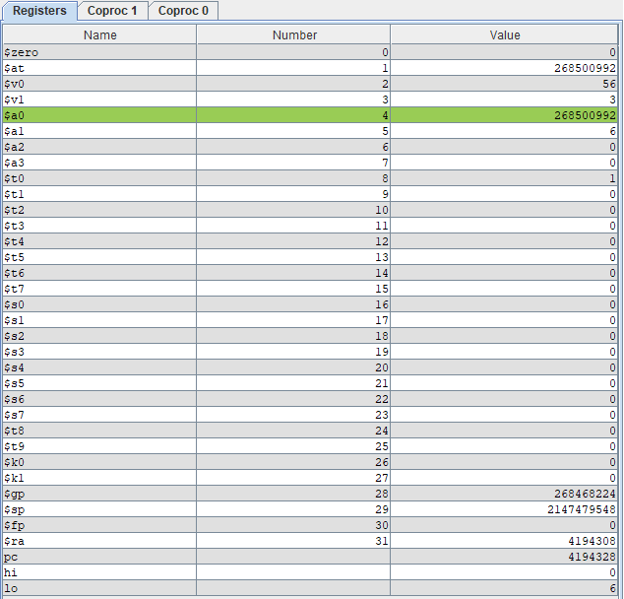

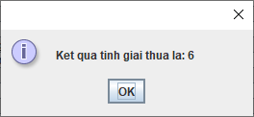

Chương trình đưa ra kết quả chính xác 3! = 6

Stack :

At the begin of WRAP, $sp = 2147479548

|  |  |
| --- | --- |
|  | |
|  | |
|  | |
|  | |
|  | |
|  | |
|  | |
| $ra (4) | |
| $fp | |
|  |  |

214747940 <- new $sp (3) addi $sp, $sp, -8  
2147479544 (1) sw $fp, -4($sp)  
2147479548 🡨 new $fp (2) addi $fp, $sp, 0

At the end of WRAP, $sp = 2147479540

|  |  |
| --- | --- |
| $a0 |  |
| $ra | |
| $fp | |
| $a0 |  |
| $ra | |
| $fp | |
| $ra |  |
| $fp | |
|  | |

🡨 new $fp

🡨 new $fp

4194308 **🡪**restore $ra **(5)**2147479548**🡪**restore $fp **(7)**2147479540 **🡪**restore $sp **(6)**